ORDER FORM FOR BULBS
Dryad Nursery,
130, Prince Rupert Drive, Tockwith, YORK YO26 7PU
PLEASE USE BLOCK CAPITALS‼!

Plant Name | No. | Price each | Total
 |  | P & P
(Continue overleaf if necessary) |  | TOTAL

tick
Please unsubscribe me, I no longer wish to receive lists
Name:
Address:
Telephone No*:
Email*:
*optional
PLEASE MAKE CHEQUES PAYABLE TO MRS A WRIGHT
SEE OVERLEAF FOR HOW TO LIMIT A CHEQUE
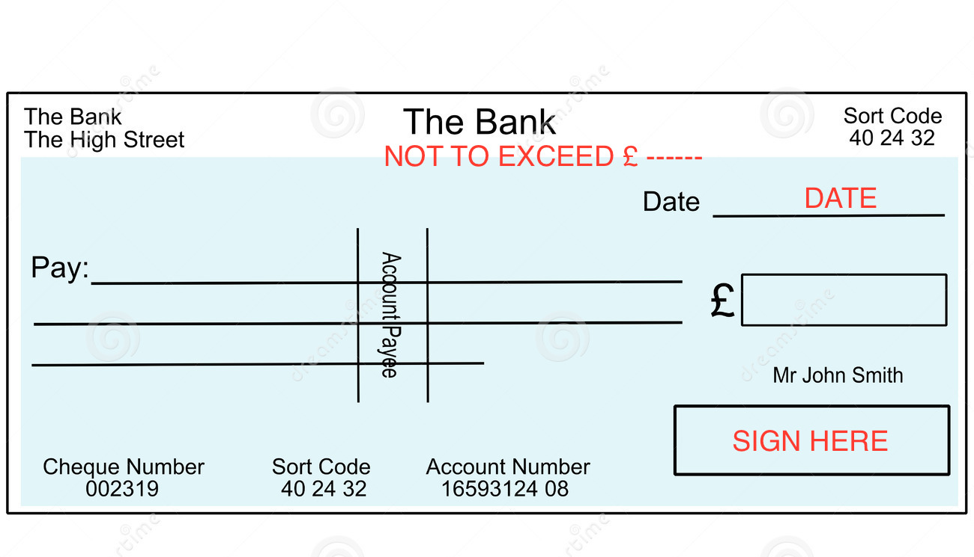

Put the amount you think you will owe in the ‘Not to exceed’ line, date and sign the cheque in the usual way.

Plant Name | No. | Price each | Total

